**EVM TEMPLATE USER MANUAL**

*Summary description*

Every project needs to answer the question: How much work was accomplished? Earned value management (EVM) is a quantitative technique methodology for controlling a project; it relies on measuring the performance of work using a work breakdown structure (WBS) and includes an integrated schedule and budget based on the project WBS. However, we must keep in mind that this methodology provides an “estimate,” not an exact number. This estimate varies according the performance of the project.

Earned value management is used in project management to measure progress of a project with respect to cost. This template runs a basic earned value analysis and monitors spending over the life of a project. This EVM worksheet is used for planning and tracking of your spending.

Start by adding tasks to the EVM table and entering the amounts that will be spent on the tasks each period.

After you are done defining the tasks and the budget, enter the same set of tasks in the PV (Planned Value), EV (Earned Value) and AC (Actual Cost) worksheets.

At the end of each period, you'll enter a percentage complete for each task in the % PV+EV worksheet, and the amount spent on each task during the period in the AC worksheet.

Update the pivot table on Graphic worksheet and analyze the graph, comparing the EV and AC to the Planned Value.

*Definitions/Instructions*

This workbook has nine (9) sheets:



1. **TERMS**: Contains basic terminology for Earned Value Management according to PMI.
2. **Graphic:** Contains the “S-Curve” and the key indicators relatives to project performance.
3. **EVM:** Contains the WBS (work breakdown structure) with the different levels (deliverables and work package); also has a unique ID for each activity, the cost and quantity per activity, and the budget (BAC) as a result. This first 7 columns are the headers for the other sheets to keep an order. This sheet contains a specific time shot of the project.
4. **DB:** Reorganize the data so it can be graphic easily.
5. **PV:** Contains the Planned Values for each activity.
6. **EV:** Contains the Earned Value according to the progress of the project.
7. **AC:** Contains the Actual Cost of each activity.
8. **%PV + EV:** Contains the PV and the EV values expressed in percentage; it affects the values in the PV and EV sheets accordingly.
9. **PROGRESS CHECKER:** this sheet its useful to verify that the information in PV-EV is coherent.

USE:

1. Establish the WBS with its deliverables and work packages in order to build BAC for the project, from bottom to up. (EVM Sheet)
2. Use the information above to establish the headers in each sheet to keep the same structure. (PV,EV,AC,%PV+EV and PROGRESS)
3. According to the planned work, fill the “Prog” columns in the “% PV+EV” sheet so the “PV” sheet would be updating according to the values until all the activities has reached the 100% the budget allocated.
4. The EV as well as the AC must be typed according to the expenses and the progress of work. The EV must be filled in a percentage value on the “%PV+EV” sheet so that the “PROGRESS CHECKER” sheet can monitor the progress of the project.

In the “EVM” sheet, it’s possible retrieve data of the specific time inside the project using the cell “I1” where the user can select a specific month:

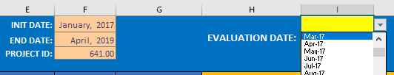

Once a specific month is selected, the AC, EV and PV columns are updated. Therefore, the variances and indices (CV,SV,CPI,SPI) show the time shot of the project at any specific period of time. Also, column P2 has a list so the user can select the method of forecast:

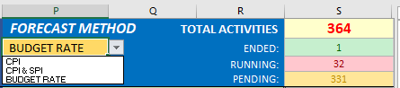

Those methods are basics explained in the “TERMS” sheet. Furthermore, the user can see the total of the activities, and which of them are finished, running or pending (without starting) at the time selected above.

On the “Graphic” sheet, there are pivot tables based on the “DB” sheet, which provides the information for the graphics:

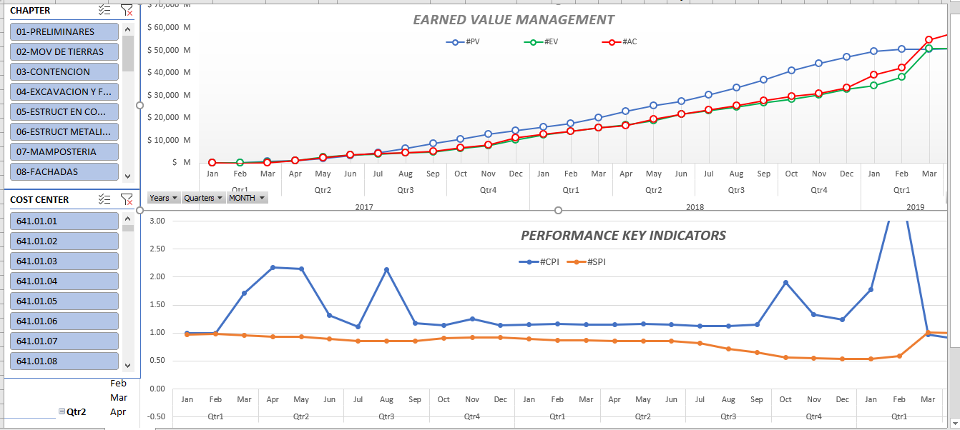

Put two slicers on the left side so the user can analyze and specific activity (COST CENTER) or a work package (CHAPTER).

The “DB” sheet is linked to the selected month in the “EVM” sheet so that the user can see the data from the beginning until the period desired. It’s necessary to update the pivot table in order to update the graphics.